Matthew Curry – February 3, 2019 – CS 150 Lab 1

Lab Notes

# **Introduction**

This lab featured the creation of two unrelated classes to get comfortable with using BlueJ, the main method, reading input from the command line, reading from files with the scanner class, writing to files with the Filewriter class, and using the command line.

# **Method**

The first class was designed to solve arithmetic expressions involving trigonometric functions of the form a first number multiplied by either the sine or the cosine of the second number. The main method calls a run method that uses a scanner to read user input. Then, within a try method there is a for loop that runs for that number of operations the user initially inputted. For each operations, the program reads in the first number, the operation, and the second number while printing out what was entered. Finally, it calls a method “trigOp” that contains an if statement, evaluating the first four terms of the taylor expansion of the sine function if the operator “sin” was given using the other inputted values, or instead uses the taylor expansion of the cosine to evaluate. It finally prints out the result of the operation before proceeding to the next operation, if there were to be multiple operations.

The second class reads in the first stanza of the poem “The Times are Tidy” and determines the number of words, length, and longest word in each line. It then prints out these results. The main method calls a run method containing a while loop in a try statement. The while loop runs while the text file has a next line. In the loop, the next line in the text is transferred to an array where each word represents one entry in the array. Next, the length of the array is determined, which represents the length of that particular line of the text. Next, a for loop runs that takes each word in the line, removes the punctuation in that word, determines the length of the word, and keeps track of the total amount of letters in the line. It then contains an if statement that replaces the string variable holding the longest word in the line with that word if that word is determined to be longer. Finally, it prints out these results and then proceeds to the next line.

## **Unit tests**

NA

## **Experiments conducted**

NA

# **Results (analysis of the data)**

Part 1 and Part 3: The command line compilation of the first class, as well as the evaluation of 3 expressions with one user error

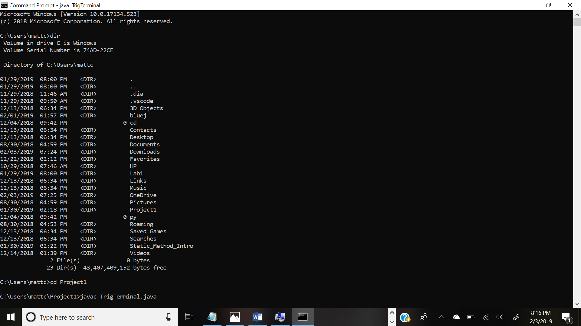

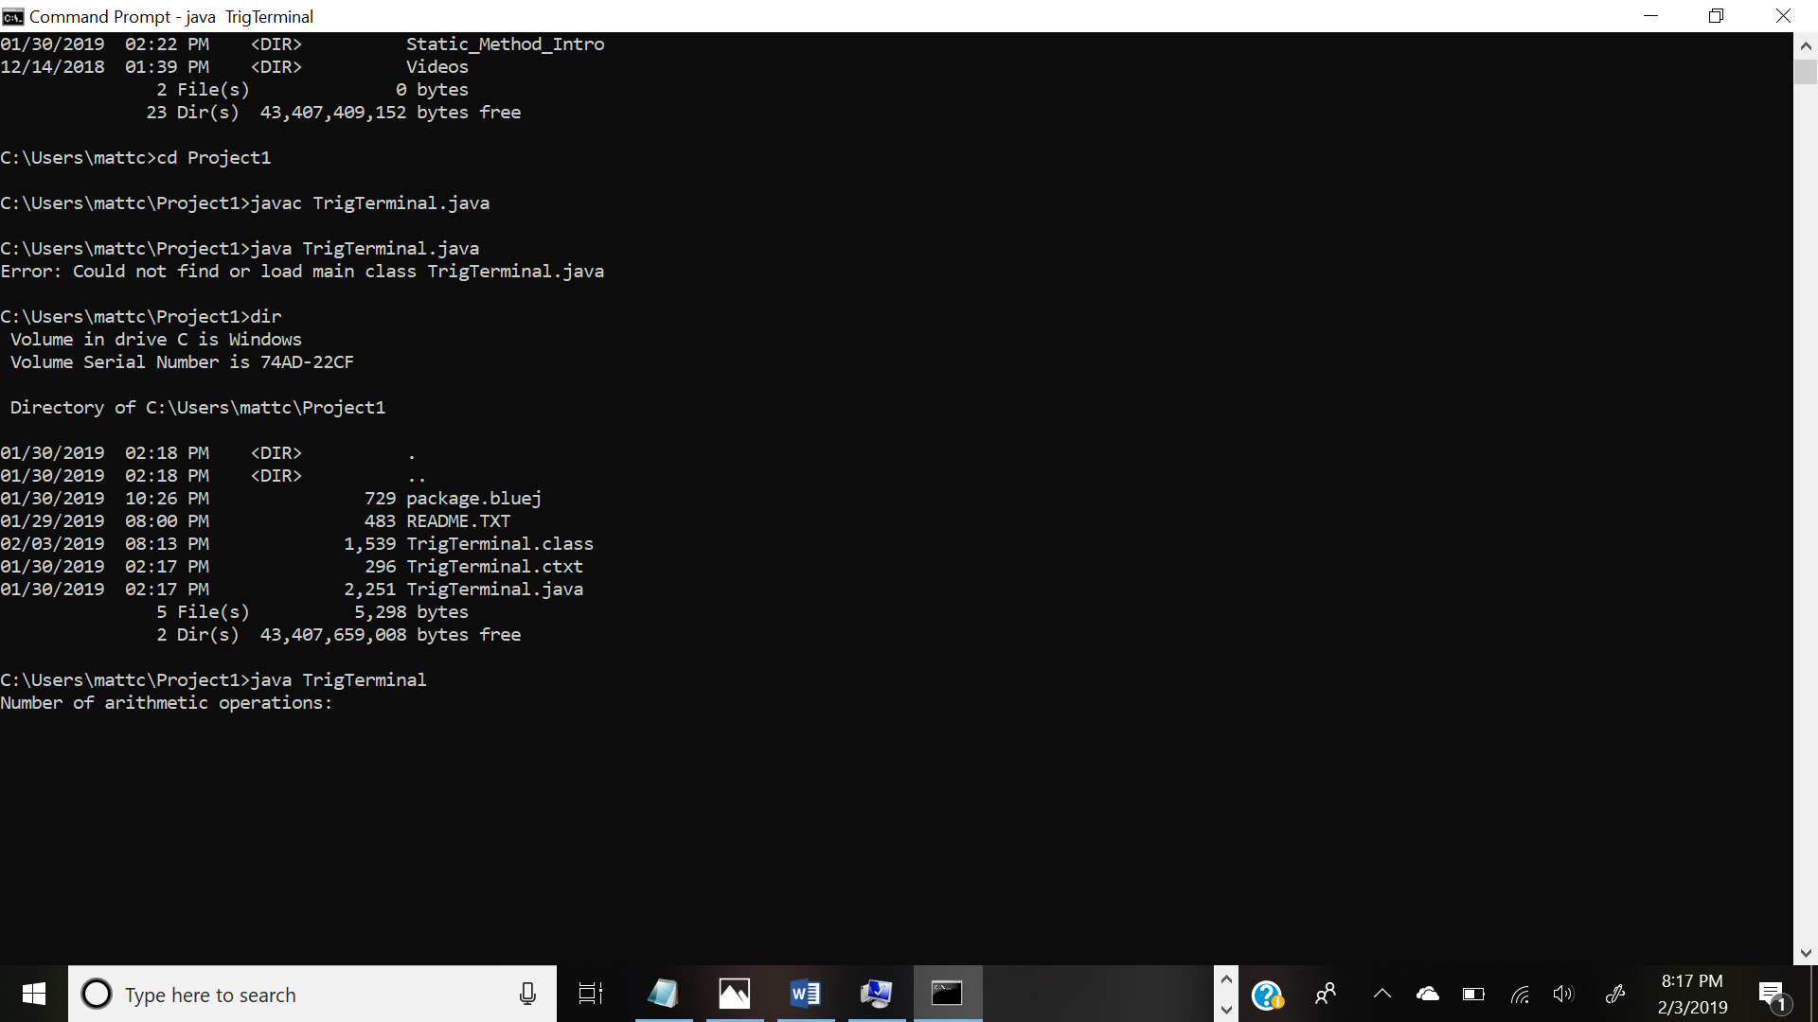

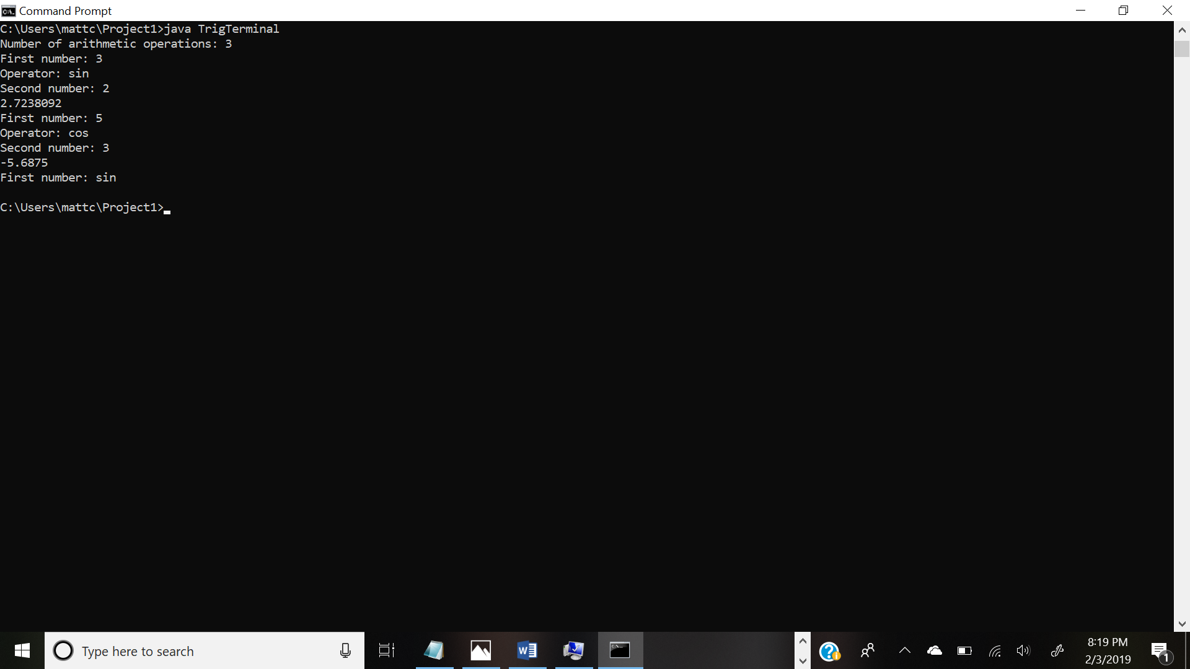

Part 2: Below is the output from the analysis of “The Times are Tidy”

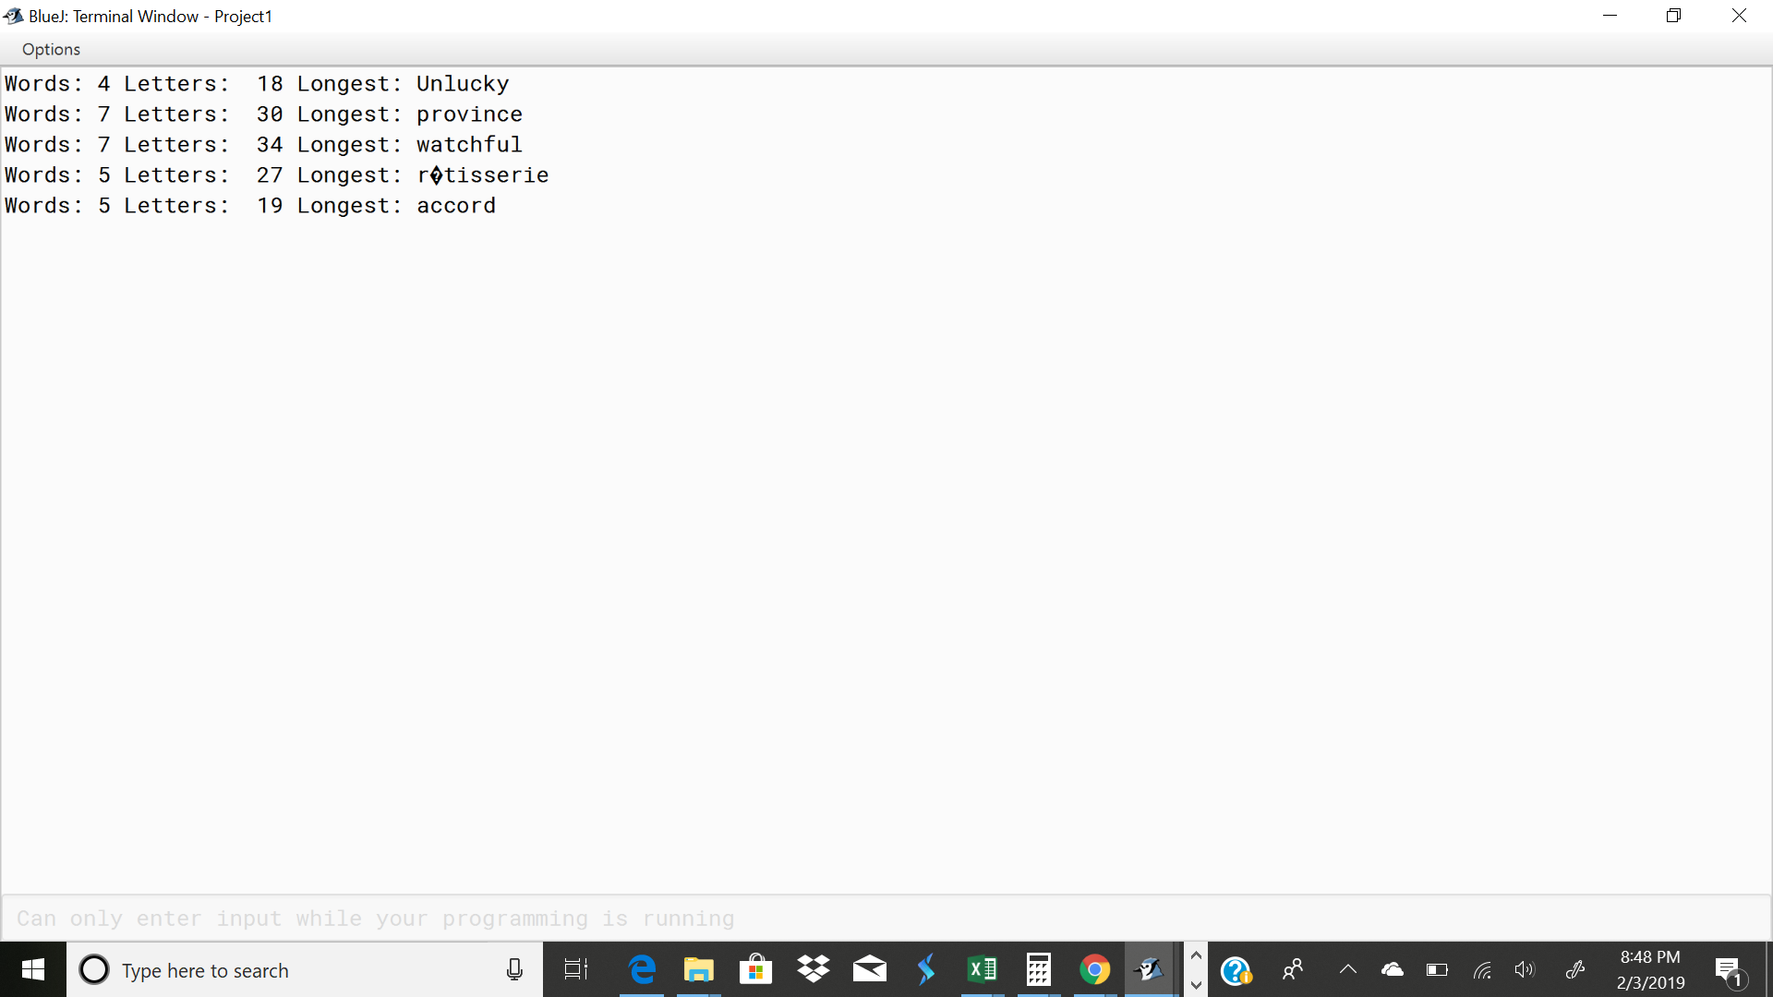**Conclusion**

NA

## **Trouble report**

NA

# **References**

NA